Assignment 1:

Pseudocode and Flowchart for Sorting Algorithm - Write pseudocode and create a flowchart for a bubble sort algorithm. Provide a brief explanation of how the algorithm works and a simple array of integers to demonstrate a dry run of your algorithm.

Solution:

**Pseudo code:**

Function BubbleSort (arr)

n = length of arr

for i from 0 to n-1

for j from 0 to n-i-1

if arr[j] > arr[j+1]

swap arr[j] and arr[j+1]

end for

end for

return arr

**Flow Chart:**

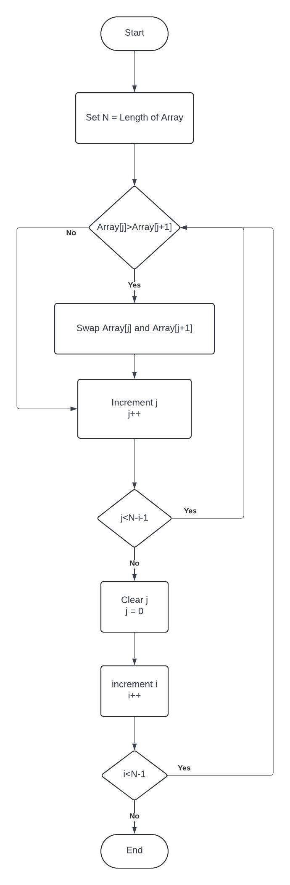­­­­­

**Explanation:**

Bubble sort is a simple sorting algorithm that repeatedly steps through the list, compares adjacent elements, and swaps them if they are in the wrong order. The pass through the list is repeated until the list is sorted. The name "bubble" sort comes from the way smaller elements "bubble" to the top of the list during each pass.

Here's how the algorithm works:

1. Start with the first element (index 0) of the array.
2. Compare it with the next element (index 1). If the next element is smaller, swap them.
3. Move to the next pair of elements and repeat the comparison and swap if necessary.
4. Continue this process until the end of the array.
5. After the first pass, the largest element will be at the end of the array.
6. Repeat the process for the remaining elements (excluding the last one).
7. Continue this process until the entire array is sorted.

**Dry Run Example:**

Consider the array: [5, 3, 8, 4, 2]

* Pass 1: [3, 5, 4, 2, 8]
* Pass 2: [3, 4, 2, 5, 8]
* Pass 3: [3, 2, 4, 5, 8]
* Pass 4: [2, 3, 4, 5, 8]

The array is now sorted in ascending order.